Presence Exchange Connector
Register under: https://portal.azure.com an application as shown in the screenshot below.
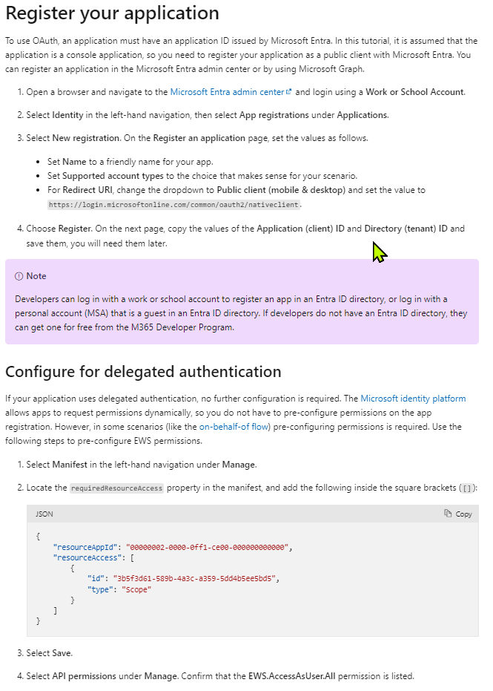
Capture from the APP the following details:
Tenant-ID
App-ID
Secret

