Adaptation for Anonymous Calls
1. Regex Adaptation need to be activated on SM Global Settings
2. Create two Condtions
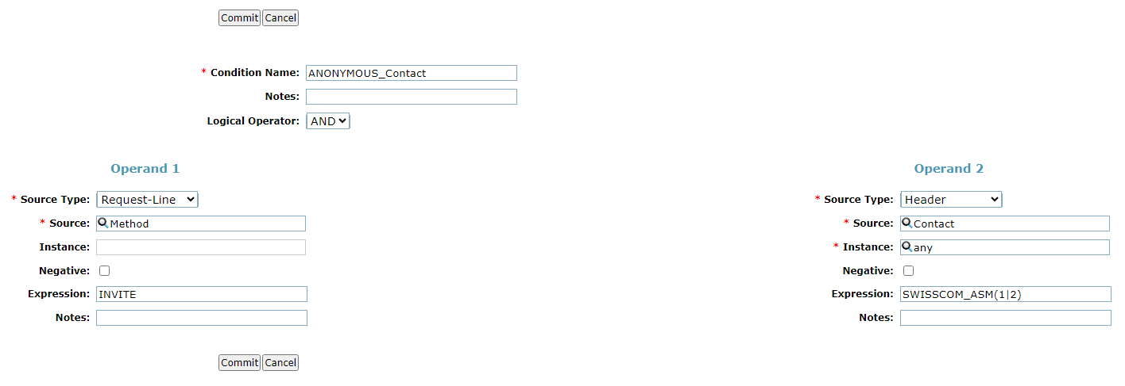
and
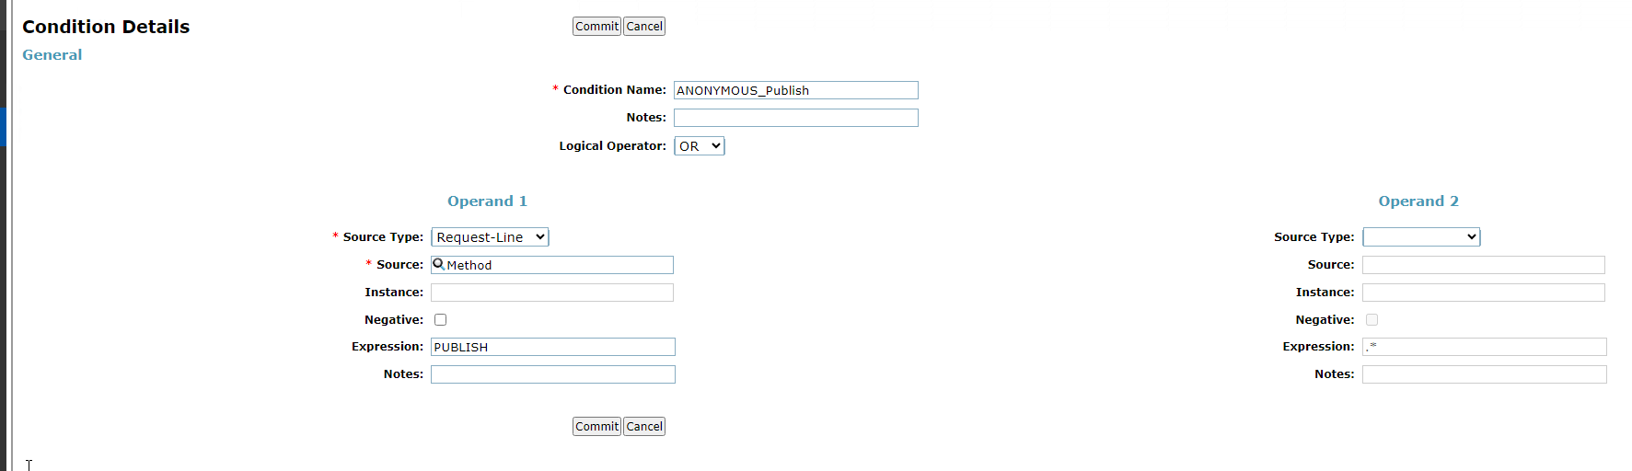
3. Create REGEX Adaptation with 2 Entries
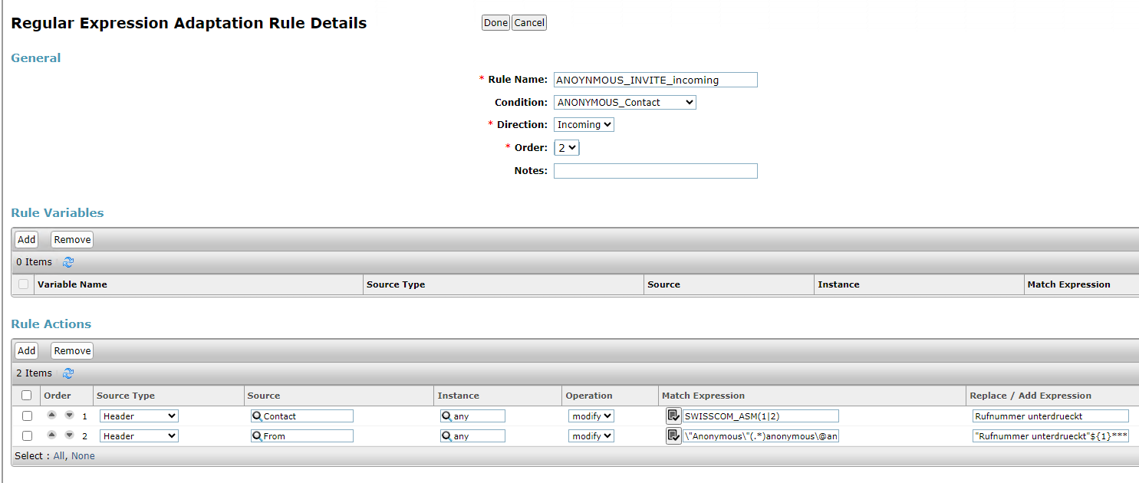
Match_Expression: <Public_Trunk_Name>
and
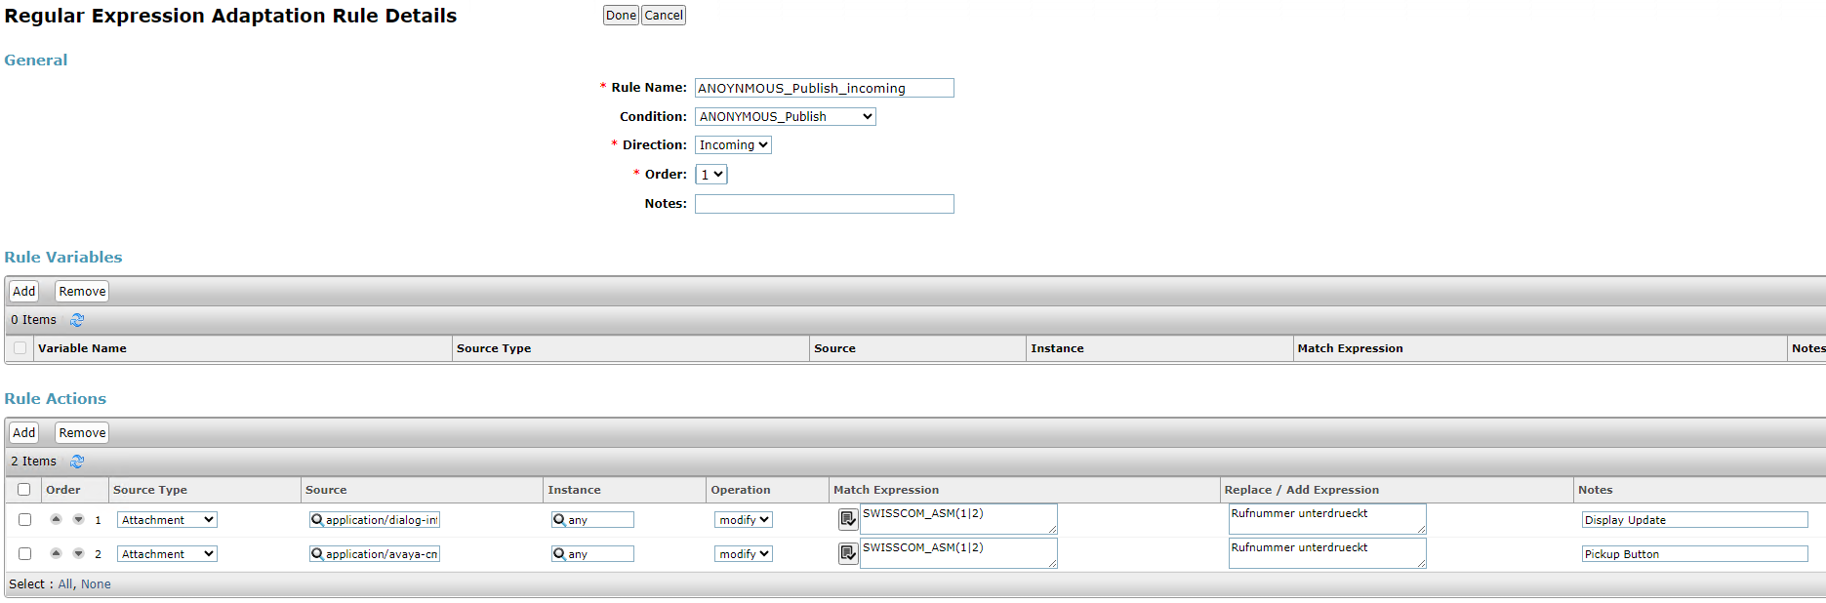
Source:
1st: application/dialog-info+xml
2nd: application/avaya-cm-feature-status+xml
Match_Expression: <Public_Trunk_Name>
3. Assign Adaptation to OPTIM SIP Entity

